*Simulation Task 2*

*Report*

*Group Names:*

*1. Ahmad Magdy Muhammad Sec (1)*

*2. Ahmad AbdEl-Latif Mhana Sec (1)*

*3. Ahmad Alaa AbdEl-Wahab Sec(1)*

*Problem Formulation*

*We want to help a Newspaper sells man because he can’t decide how many paper he should buy, so that he gets the highest profit.*

*This should be done by getting the day distribution that specifies the day’s type, then for every day type, a demand distribution, then we’ll run the simulation for a range of Inventory number, each for number of days, and we’ll calculate the total profit over each Inventory Number, so that we can decide which run is the best for the Newspaper sells man.*

*Objective*

*We want to decide the number of papers to buy to achieve the highest profit overall the day for this Newspaper sells man.*

*We can achieve this by running a simulation with all possible Inventory numbers the Newspaper Sells man can buy, and then decide which the best, according to the total profit is.*

*Model Conceptualization*

*-First of all we should take the input data from the user.*

*-then we’ll create a Model for each inventory number,*

*-we’ll rune each of the inventory models, for the number of the simulation days, creating: dayType, demand, revenue, lostProfit, excessDemand, salvageFromScrap, profit, and of course the totals values for this model: totalLostprofit, totalExcessDemand, totalSalvageFromScrap and totalProfit*

*-Create graphs that represents each model profit over the simulation days,*

*And another one the show the totalProfit for all the inventoryNumber, and from it, we can know which number is the best for the Newspaper sells man.*

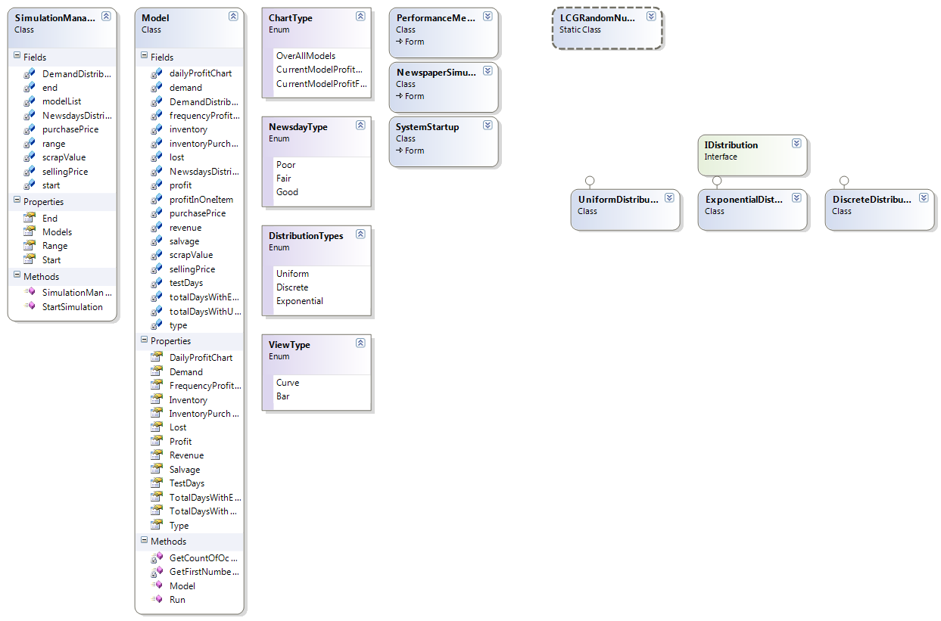

*Experimental Design*

*Test Case 1*

|  |  |
| --- | --- |
| *Inventory Values* | *40-100* |
| *Purchase Price(¢)* | *33* |
| *Sell Price(¢)* | *50* |
| *Scrap Value(¢)* | *5* |

|  |  |
| --- | --- |
| *Day Type* | *Probability* |
| *Poor* | *0.35* |
| *Fair* | *0.45* |
| *Good* | *0.2* |

|  |  |  |  |
| --- | --- | --- | --- |
| *Demand* | *Poor* | *Fair* | *Good* |
| *40* | *0.03* | *0.1* | *0.44* |
| *50* | *0.05* | *0.18* | *0.22* |
| *60* | *0.15* | *0.4* | *0.16* |
| *70* | *0.2* | *0.2* | *0.12* |
| *80* | *0.35* | *0.08* | *0.06* |
| *90* | *0.15* | *0.04* | *0* |
| *100* | *0.07* | *0* | *0* |

*Results*

*Totals*

|  |  |  |  |  |  |
| --- | --- | --- | --- | --- | --- |
| *Inventory* | *Buy* | *Sell* | *Lost* | *Scrap* | *Profit* |
| *40* | *264* | *400* | *93.5* | *0* | *42.5* |
| *50* | *330* | *475* | *37.4* | *2.5* | *110.1* |
| *60* | *396* | *550* | *30.6* | *5* | *128.4* |
| *70* | *462* | *625* | *13.6* | *7.5* | *156.9* |
| *80* | *528* | *605* | *0* | *19.5* | *96.5* |
| *90* | *594* | *655* | *3.4* | *24.5* | *82.1* |
| *100* | *660* | *655* | *0* | *34.5* | *29.5* |

*The Greater value goes around 50-70*

*With max Profit @ 70 = 156.9*

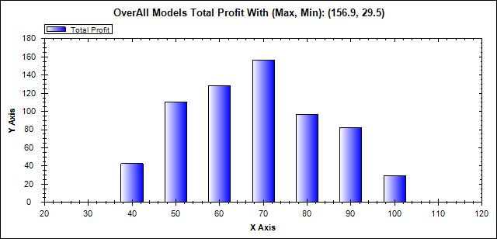

*Test Case 2*

|  |  |
| --- | --- |
| *Inventory Values* | *40-80* |
| *Purchase Price(¢)* | *33* |
| *Sell Price(¢)* | *50* |
| *Scrap Value(¢)* | *5* |

|  |  |
| --- | --- |
| Poor | 0.25 |
| Fair | 0.4 |
| Good | 0.35 |

|  |  |  |  |
| --- | --- | --- | --- |
| 40 | 0.10 | 0.10 | 0.44 |
| 50 | 0.20 | 0.20 | 0.22 |
| 60 | 0.15 | 0.40 | 0.16 |
| 70 | 0.2 | 0.20 | 0.12 |
| 80 | 0.35 | 0.10 | 0.06 |

*Results*

*Totals*

|  |  |  |  |  |  |
| --- | --- | --- | --- | --- | --- |
| *Inventory* | *Buy* | *Sell* | *Lost* | *Scrap* | *Profit* |
| *40* | *264* | *400* | *79.5* | *0* | *56.5* |
| *50* | *330* | *495* | *51* | *0.5* | *114.5* |
| *60* | *396* | *545* | *22.1* | *5.5* | *132.4* |
| *70* | *462* | *615* | *8.5* | *8.5* | *153* |
| *80* | *528* | *620* | *0* | *18* | *110* |

*The Greater value goes around 50-70*

*With max Profit @ 70 = 153*

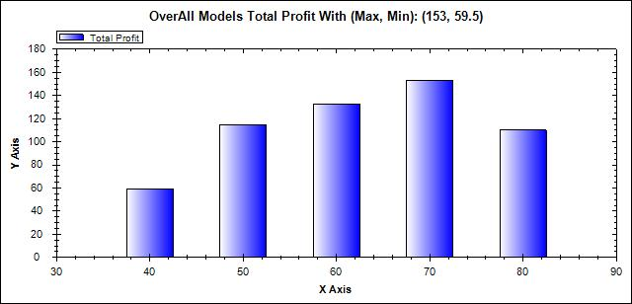

*Screenshots*

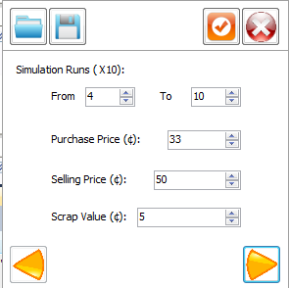

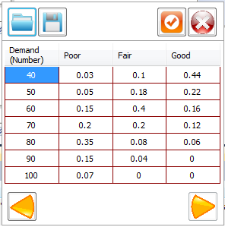

*Result Analysis & Conclusion*

*As seen from the simulation with values from 40 to 100 & 40 - 80*

*The Max profit was around 70 newspapers bought overall the test values, so I am going to take 70 as the conclusion results.*